CMSC 203 Fall 2019
Memory Mapping Worksheet

- Draw the memory map of the following one-dimensional array of type int.
int[] x = new int[8];

Stack: Heap:

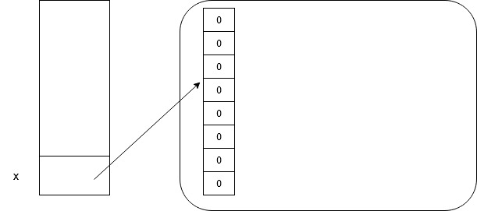

- Draw the memory map of the following two-dimensional ragged array of ints.

int[][] y = {{4, 8, 15}, {16, 23, 42, 10}, {8, 30}};

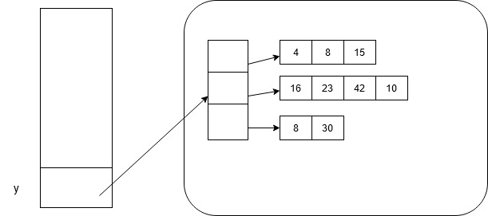
Stack: Heap:

- Draw the memory map of the following one-dimensional array of type String.

String[] z = new String[4];
for (int i = 0; i < z.length; i++) {
z[i] = "element " + i;
}
Stack: Heap:
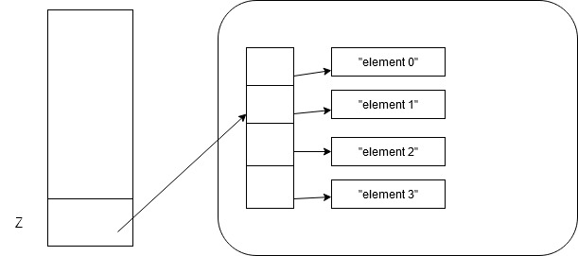

- a. Write a shallow copy of the following in code. (Assume the five animal objects are already instantiated.)
Animal[] zoo = {tiger1, elephant2, giraffe3, monkey4, ape5};
Animal[] copy;

Animal[] zoo = {tiger1, elephant2, giraffe3, monkey4, ape5};
Animal[] copy = new Animal[zoo.length];
for (int i = 0; i<copy.length; i++){
copy[i] = zoo[i];
}

- Draw the memory map.
Stack: Heap:
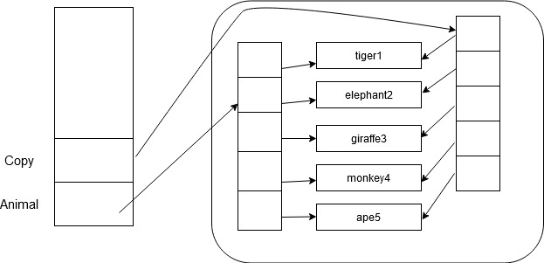

- a. Write the deep copy of the following in code.
Animal[] zoo = {tiger1, elephant2, giraffe3, monkey4, ape5};
Animal[] copy;

Animal[] zoo = {tiger1, elephant2, giraffe3, monkey4, ape5};
Animal[] copy = new Animal[zoo.length];
for (int i = 0; i<copy.length; i++){
copy[i] = new Animal[zoo[i]];
}

- Draw the memory map.
Stack: Heap:
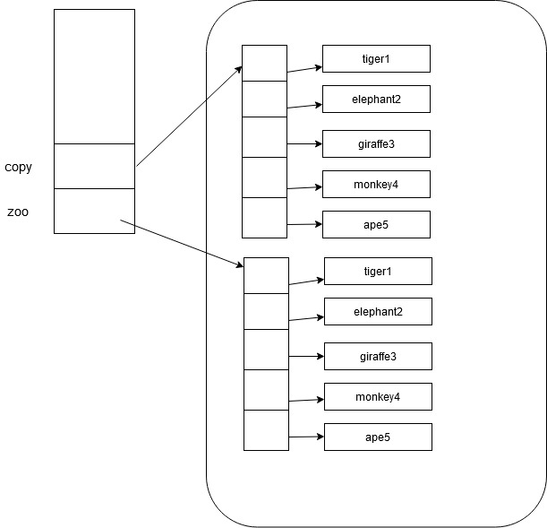

- What is garbage collection? Where does it happen?
Garbage collection is automatic and part of the JVM. It is running continuously while the program is running. It frees up memory from unreferenced objects. To give an example, memory is first allocated to int a = 3, but it’s not used anywhere in the program, so the JVM reclaims that memory back.

- What is the difference between the two operators, equals() and ==?
.equals() checks if the values are the same while == checks if both objects point to the same memory address.

